1.Delete Unanmed columns

In the df we have one unnamed column

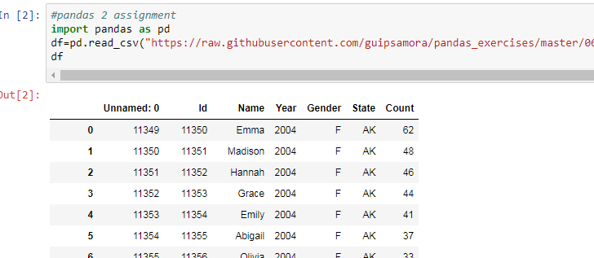

After Dropping:

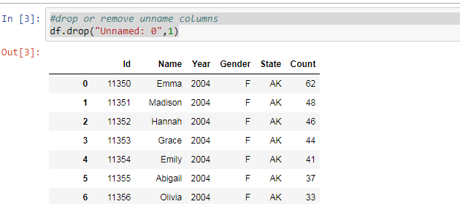

#show the distribution of Male/Female

##show the distribution of Male/Female

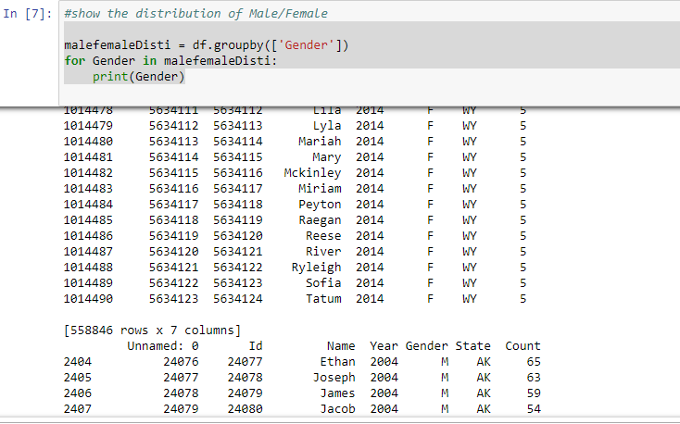

#show the top 5 most preferred names

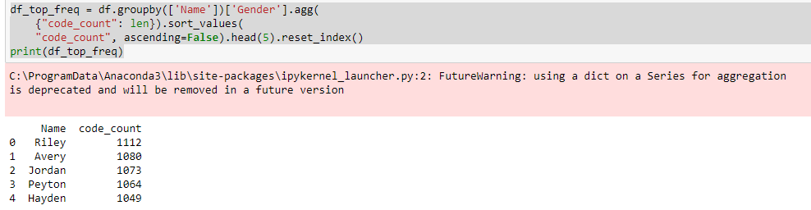

#What is the median name occurence in the dataframe

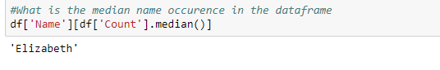

5#Distribution of male and female born count by states

